Smart Expense Approval Platform

Problem Statement
1.1 Slow Expense Submissions
Employees sometimes experience delays because the application and database take longer to process requests under increasing workload.
Reasoning:
- Increasing number of requests
- Application and database processing load
- Higher latency
1.2 Missed Manager Updates
Managers may miss important expense updates because the current notification process is not sufficiently reliable or real-time.
Reasoning:
- Notification delays or failures
- No reliable asynchronous event processing
- Important updates may be missed
1.3 Poor Responsiveness Under High Load
The platform becomes slow or unresponsive when many employees submit expense claims simultaneously, overloading the application and database.
Reasoning:
- Many simultaneous requests
- Application/database bottlenecks
- Limited scalability
- Increased latency

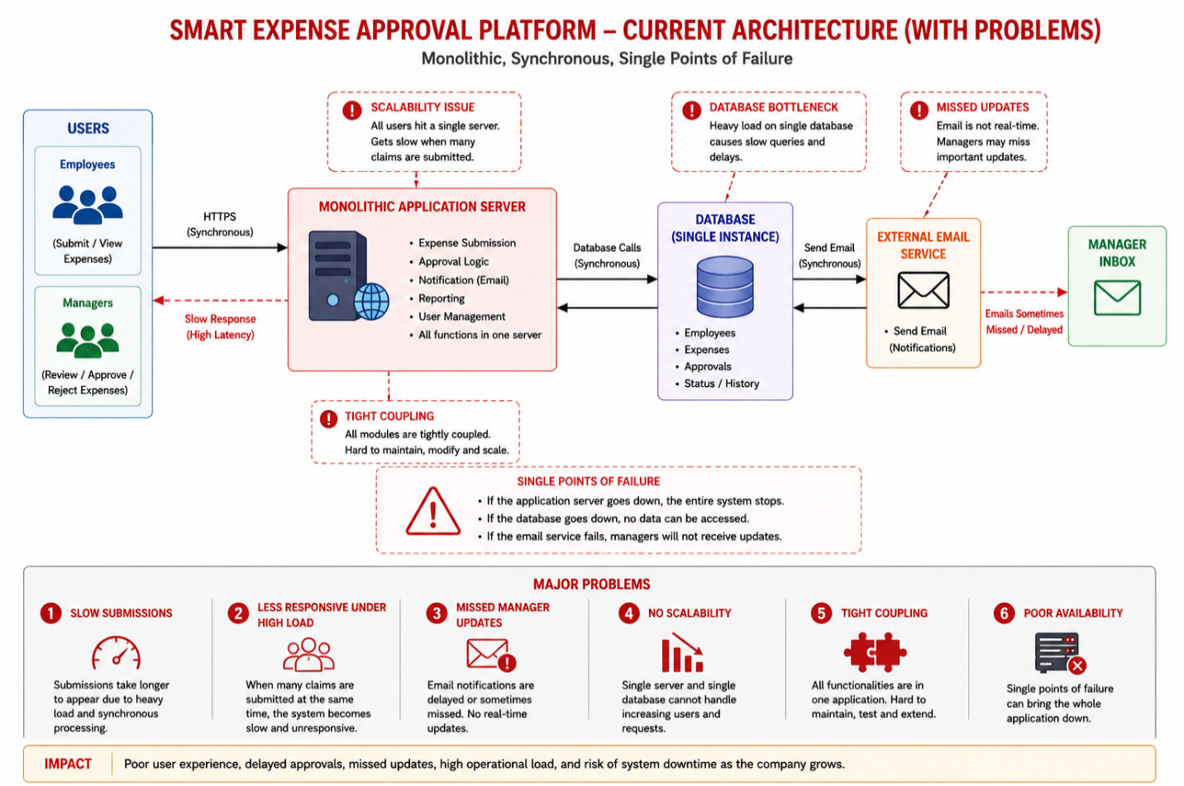

Proposed Solution
- HTTPS - Secures communication between employees, managers, and the platform.
- Load Balancer - Distributes incoming requests across multiple application instances to prevent overload.
- Multiple Expense Service Instances - Allows multiple instances to process requests simultaneously and improves scalability.
- Docker - Packages the Expense Service into containers for consistent and easy deployment.
- Kubernetes - Manages, scales, and automatically restarts containers when required.
- Database - Stores user, expense, and approval information reliably.
- Message Broker - Enables reliable asynchronous communication between services.
- Event-Driven Architecture - Uses events such as ExpenseSubmitted, ExpenseApproved, and ExpenseRejected to trigger independent services.
- Notification Service - Sends expense updates to managers and can use WebSocket for real-time notifications.

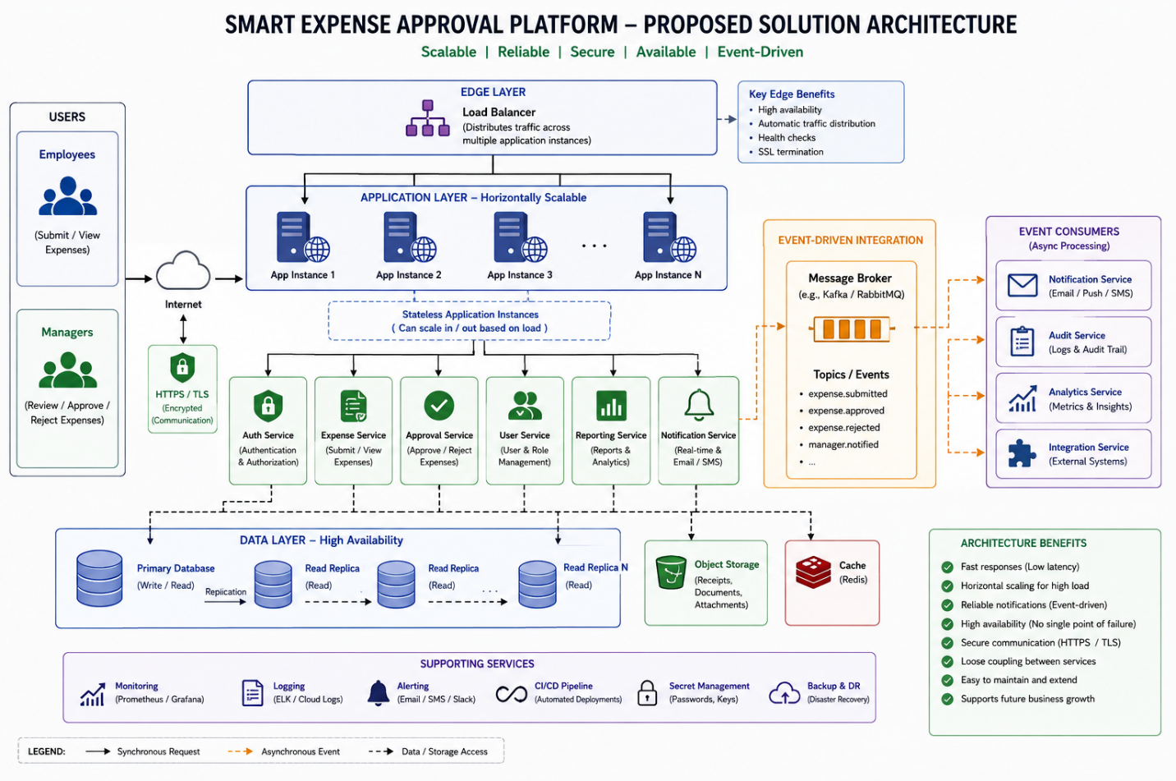

3. Assumptions
- Users - The platform has two main user types: employees who submit expenses and managers who approve or reject them.
- Growing Usage - The number of employees and expense claims will increase over time, requiring the system to scale.
- Secure Communication - All user-to-platform communication is assumed to use HTTPS.
- Event-Based Updates - Important actions such as ExpenseSubmitted, ExpenseApproved, and ExpenseRejected generate events.
- Message Broker - A message broker such as Kafka, RabbitMQ, or Azure Service Bus is available for asynchronous event processing.
- Containerized Services - Application services can be packaged and deployed using Docker containers.
- Scalable Infrastructure - Multiple application instances can be deployed behind a load balancer to handle increasing traffic.
- Real-Time Notifications - Managers are expected to receive important expense updates quickly; WebSocket may be used where real-time updates are required.
- High Availability - Critical infrastructure such as the application and database is assumed to have appropriate redundancy and backup mechanisms in a production environment.

